33.10: a) 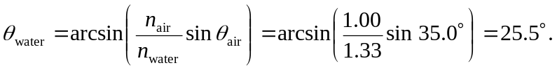
b) This calculation has no dependence on the glass because we can omit that step in the

